|  |  |
| --- | --- |
| Canon RF 50mm f/1.2L USM Lens  Ống Kính Canon RF 50mm f/1.2L USM  Canon RF 50mm f1.2L USM 1 Canon RF 50mm f1.2L USM 4 Canon RF 50mm f1.2L USM 3 Canon RF 50mm f1.2L USM 2 | **Featured information:**  Ring-shaped ultrasonic focusing motor  Aperture: f/1.2 - f/16  One UD lens, One aspherical lens  RF/Full-Frame Lens  Price : $ 1900  **Specifications:**  Focal distance  50mm  Largest Aperture  f/1.2  Smallest Aperture  f/16  Lens Mount  Canon RF  Lens Format  Full-Frame  View  46°  Minimum Focus Distance  40cm  Magnification  0.19x  Optical Components  15 Elements in 9 Groups  Number of Mouth Blades  ten  Focus Type  Autofocus  Anti-Vibration |

**Overview:**

Canon RF 50mm f/1.2L USM is a lens used for Canon's RF-mount full-frame mirrorless cameras. With impressive technical specifications, this lens will definitely give you exciting experiences in the process of exploring and capturing memorable moments in life.

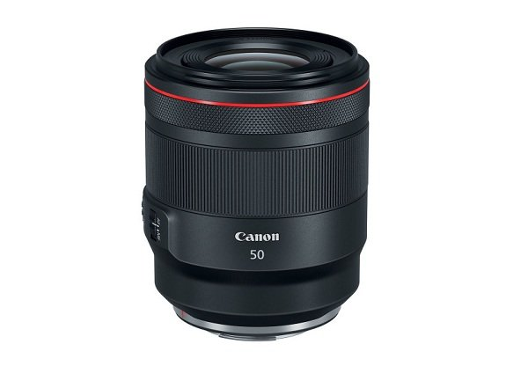

The Canon RF 50mm f/1.2L USM is a 50mm fixed focal length lens with full-frame optical performance that delivers images with greater sharpness and detail. The aperture can be opened to F/1.2 to help highlight the subject, giving the best image quality, suitable for filmmakers or photographers shooting with a thin depth of field.

With a focal length of 50mm and flexible aperture up to F/1.2, users can take a variety of photos with many different styles even in difficult lighting conditions such as street photography...



This mirrorless lens is composed of 15 elements arranged in 9 groups, including 1 Ultra-Low Dispersion (UD) lens that helps reduce chromatic aberrations and color fringing, helping the resulting image to be sharper. Clearest and most color accurate. Combined with an aspherical lens to reduce spherical aberration and image distortion, thereby improving image sharpness.

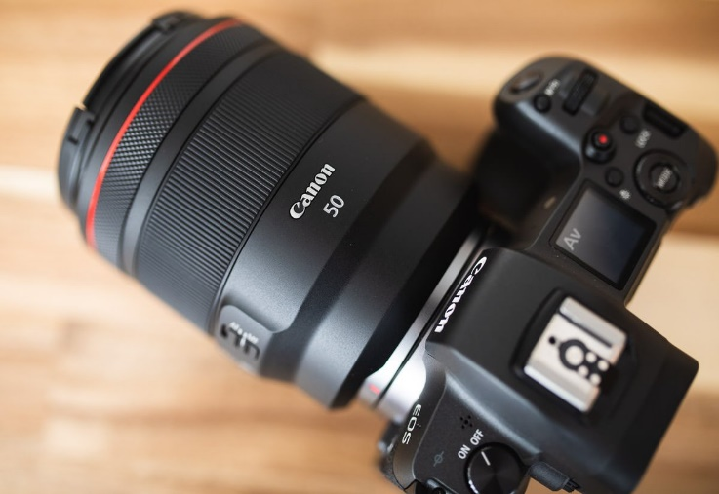

Belonging to Canon's L series lens, the 50mm f/1.2L USM RF mount lens with optimal design not only possesses a beautiful design but also has effective weather resistance, dust and humidity resistance, thereby providing Can be comfortably used in many different harsh environments without worrying about damage.